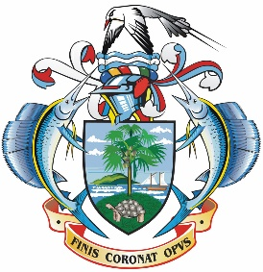 | 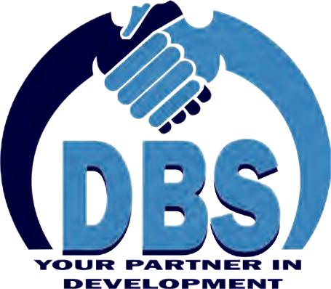 | 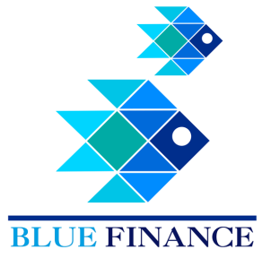

Eligible Activities under the Blue Investment Fund
(Issue #1_20191219)

The Development Bank of Seychelles in partnership with the Department of Blue Economy is pleased to announce that the Blue Investment Fund is open and will now remain open for applications throughout the year, meaning that there are no deadlines for submission!

The Blue Investment Fund is making available loans to support investment by local enterprises in sustainable fisheries value chains

Maximum Loan amount  Minimum Loan amount  Interest rate  Repayment period | US$ 3,000,000 (in SCR equivalent)  US$ 10,000 (in SCR equivalent)  4% per annum  Maximum 15 years
:

If you are interested in a loan for your business enterprise, please read on

Purpose of the Blue Investment Fund
Fisheries are vital to the social, economic and cultural wellbeing of Seychellois. The sector is a major pillar of the economy, providing employment for around 17% of the population. Fish and fish products constitute more than 90% of our exports, while still allowing for fish to be a significant source of protein and nutrition to local diets. However, there are increasing concerns over the sustainability of many of our key fisheries. Recent studies indicate that some fish populations have declined by more than 60% in the last three decades, resulting in a loss of income for fishers. Fishers now have to travel further and fish for longer to obtain sufficient revenue and generate a profit.
A transition to sustainable fisheries is therefore vital for ensuring that we continue to enjoy social, economic and cultural benefits from our natural capital. Sustainable fisheries will provide for our present and future needs, while also conserving fish populations and their habitats and marine ecosystems. Securing the rights of fishers to access fisheries resources is a key element in achieving sustainable fisheries.
The Blue Investment Fund is intended to support diversification and expansion of fisheries value chains in Seychelles. It has been designed to only allow investments in value chains that are supported by managed fisheries, or investments in pre- and post-production components of the value chains that will add value without creating additional pressure on vulnerable fish populations. This will allow for continued economic growth in the sector while the main challenges facing the sector are being addressed through strengthening of policy and improved fisheries management.
The Blue Investment Fund has been designed around key principles for selecting eligible activities and evaluating proposals, which are then further defined on the basis of information from commissioned studies (see Annex 1):
- Firstly, eligible activities that can be supported by the fund are dependent on governance and management prerequisites being met by the fishery. Robust policy, regulatory frameworks and fisheries management are essential, especially for investments in fish processing activities;
- Secondly, due to overcapacity in certain fisheries, i.e. too many boats for the available resources, the fund cannot be used for investments in fishing boats and fishing gear;
- Thirdly, specifying eligible activities for investment under the fund is based on robust knowledge concerning the potential for value chain expansion, in terms of the productivity and status of underlying resource, and the potential for enhancement of value chain performance (i.e. the opportunity to add margin between landed and sell-on prices).

- Lastly, in line with principles for a Blue Economy, the fund seeks to foster innovation in the way of doing business and will support enterprises that can demonstrate social and environmental benefits as well as economic returns. Propositions based on responsible business practices will have the greatest chance of success in securing the loan.
To promote innovation and nurture a new generation of responsible business enterprises, the Blue Investment Fund is partnered with the Blue Grants Funds administered by the Seychelles Conservation and Climate Adaptation Trust (SeyCCAT). These two funds, both capitalised by the proceeds of the Blue Bond, are providing financing to secure a transition to sustainable fisheries. Please refer to the section below on the financing structure to see how your business can benefit from this unique opportunity of complimentary loan and grant facilities.

Applicant Eligibility
We are now inviting applications for the loans. Eligible applicants are limited to:
- Seychellois individuals
- Locally registered civil society organizations
- Locally registered firms, including
  - small and medium-sized fisheries enterprises
  - public-private partnerships
  - local-foreign joint ventures

Eligible Activities and Value-chains
Your loan application must reference the eligible activities. In the case of processing activities for fish harvested from wild stocks, you must also reference the value chains that apply to your project.
If your project does not involve processing, please use only the first table to select your reference code, e.g. AJ for waste and energy efficiency projects. If your project does involve processing of fish harvested from wild stocks, please select ‘AI’ from the first table and also the relevant reference code from the second table, e.g. AIVC4 for processing billfish value added.
Loans from the BIF can currently support the following activities:
 | Code | Eligible activities
Scientific services | AA  AB | - Business enterprises that provide scientific support to the fisheries sector including services related to fisheries research, management planning and fisheries monitoring (including vessel monitoring systems)  - Businesses that provide food technology and laboratory analytical services for seafood product research, development and labelling
Logistical services | AC  AD  AE  AF | - Businesses that provide offloading, storage and delivery services to improve cold chain management including cargo handling services  - Enterprises that provide sorting and refreezing facilities as an ancillary service to processors and exporters of bycatch  - Enterprises that provide fleet and crew management services  - Business enterprises that provide packaging, distribution, marketing and sales services
Processing | AG  AH  AI | - Businesses developing new facilities, or rehabilitating existing facilities, that are engaged in primary or secondary fish processing for eligible value chains (see next table)  - Enterprises investing in processes and technology to improve waste and energy efficiency  - Existing businesses that plan to upgrade existing processing facilities for HACCP or EU certification to improve market options
Market access | AJ  AK  AL | - Industry-led investments in fishery improvement projects and assessment for internationally recognised certification schemes (e.g. Marine Stewardship Council)  - Enterprises providing services in market research, brand building, strategy development and sector intelligence  - We can also support investment in specialised technologies for accessing markets such as electronic sales and auction platforms

Processing activities for fish harvested from wild stocks are currently limited to the following value chains:
 | Code | Eligible value-chains
Fish Processing (from wild-caught fish) | VC1  VC2  VC3  VC4  VC5 | - Purse seine tuna fishery bycatch: whole frozen exports, value-added beneficiated products (e.g. burgers), dried products, mixed products  - Tuna loans frozen: tuna purchased for loining and marketing, or tuna loining services  - Tuna headed and gutted fresh product  - Billfish value-added product  - Longline tuna fishery bycatch

Important Note: Eligible activities and value chains for loans are subject to change. Please ensure that you have downloaded this document at the time of submission and checked the eligibility of your project.

Exclusions
The following activities are excluded from financing under the fund:
- Purchases of fishing vessels
- Purchases of fishing gear
In addition, applications will be screened against an Exclusion List and excluded from further evaluation if found to meet any of the criteria listed below:
Exclusion list
Projects located within or adjacent to a protected or an ecologically sensitive area, as defined in Schedule 2 of the Environment Protection (Impact Assessment) Regulations

Projects that involve the significant conversion or degradation of critical natural habitats such as sensitive ecosystems. converting mangrove forests to aquaculture use or other land uses, or other unsustainable cutting of mangrove forests

The introduction of any new exotic marine species (note: this provision does not apply to any native and/or naturalized species, or any micro-algae that is imported as live feed)

Activities that could dangerously lead to the exposure of sensitive/critical/vulnerable habitats unsustainable or illegal fishing activities (e.g., illegally-sized nets, spear fishing, use of dynamite, etc)

Construction of permanent buildings within the wetlands

Construction of walls in or around wetlands which will interrupt water flow

The tidying of wetlands or mangroves by the removal of dead wood that serves as habitat for multiple fish species

Extraction of raw material from protected areas

Filling of wetlands within protected areas and outside in strategic landscapes.

Projects which cause significant socioeconomic impacts involving permanent involuntary resettlement resulting in relocation of people or displacement of houses or building structures; or loss, denial or restriction of access to land, crops and other economic assets; or significant loss of sources of income or means of subsistence)

Projects which physically block or restrict fishers’ access to the water (e.g., structures with walls or other shoreline obstructions or barriers that physically prevent fishers from accessing or launching their boats using customary or longstanding paths, roads or other rights of way)

Loan Application Evaluation Process and Criteria
In broad terms, qualifying applications will be expected to provide clear and demonstrable analysis of expected returns on investment and be observant of and compliant with environmental and social safeguards.
Eligible applications that are submitted in full will be subject to three key stages of evaluation. Firstly, applications will be subject to screening for environment and social safeguards by the SWIOFish3 project team. Secondly, technical evaluation of applications will be undertaken by an independent Technical Committee. Thirdly, only applications that pass technical evaluation will then proceed to DBS for financial appraisal.
Environment and Social Safeguards Screening
- Does the application conform to the eligible activities and value chains being promoted for the fund at the time of submission?
- Does the application clear checks against the exclusion list?
- Does the proposed project require environmental and social safeguards (e.g. environmental impact assessment)?
- Have environmental and social safeguards been submitted with the application, or will they be required before the loan can be approved?
Technical Evaluation
- Is the application relevant in terms of addressing priorities of the fund?
- Does the applicant demonstrate adequate capacity and does the project proposal and business plan meet requirements in terms of design and quality?
- To what extent are project objectives and activities clear and logical and do they address clearly identified market needs?
- Does the application plan adequately address market analysis and marketing strategies?
- To what extent has the application addressed principles for sustainable investment?
- Does the application provide a logical implementation plan and make adequate provisions for monitoring and evaluation?
Financial appraisal
- Are there economic and external conditions that will impact on the ability of the applicant to repay on the loan?
- Does the applicant meet required standards in terms of credit worthiness, payment history, and personal finances in order to be able to repay the loan?
- Does the applicant demonstrate adequate business management experience, relevant skills and entrepreneurial training?
- Is the business plan realistic and feasible and have market trends and risks and mitigation measures been identified?
- Is evidence for collateral (security) adequate and is the claim to the collateral a first interest?
- Is the applicant investing sufficient capital and other forms of co-financing in the project?
- Do the financial aspects of the business plan meet the required standards and is the business likely to create value and generate adequate profitability
Further details on the evaluation process and criteria can be found in the loan application materials.

Blue Finance
The Blue Investment Fund is intended to be complimented by the Blue Grants Fund administered by SeyCCAT. We encourage businesses to consider using the SeyCCAT Blue Grants Fund as an opportunity to help them prepare for a successful loan application with DBS. Entrepreneurs and businesses can benefit from Blue Grants to develop new ‘blue’ business models, undertake research and development, build capacity, conduct market analyses and test the feasibility of a business proposition. Grants can support innovations in business models in order to achieve environmental, social and economic returns.

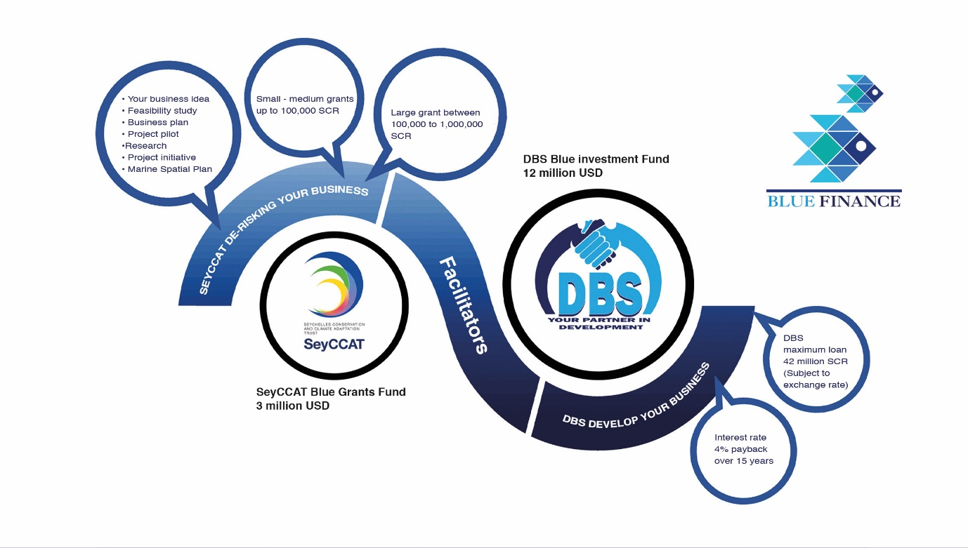

How to Apply for a BIF Loan from DBS
If you are interested in benefitting from financing to develop your business enterprise, the Blue Investment Fund is now open on a permanent basis.
Please visit the DBS website (www.dbs.sc) to download the loan application package and related materials. The loan application package comprises all the materials you will need, including details on the fund, guidelines to help you formulate and prepare your project, and the formats and guidelines for developing your business plan.
In summary, you will need to;
- Consult the Exclusion List and the Environmental and Social Safeguards documents
- Develop either a simplified or complete business plan depending on the loan amount requested (simplified business plan for loans under US$100,000 and complete business plan for loans over that amount)
- Complete the BIF business loan application form as per your application (company or individual)
- Ensure that you have the required supporting documentation and the completed BIF checklist before submitting your application
For further information, please contact us:
Development Bank of Seychelles
Tel: 4389800

Annex 1: Supporting Materials to the Blue Investment Fund
Loan Application Package
Loan application process manual http://www.dbs.sc/product-loans/blue-investment-fund-bif-scheme
Including the following 7 appendices ( http://www.dbs.sc/product-loans/blue-investment-fund-bif-scheme)
- Blue Bond-funded activities exclusion list
- Simplified business plan model
- Complete business plan model
- Environmental and social safeguards
- Business loan application form: company
- Business loan application form: individuals
- Checklist for submission

Other key materials
Environmental and Social Management Framework for SWIOFish3 Project http://www.finance.gov.sc/resources
Process Framework for SWIOFish3 Project http://www.finance.gov.sc/resources
Advance Africa Management Services. Development of Seychelles’ Seafood Value Chains. Report commissioned for the Ministry of Fisheries and Agriculture by the Third South West Indian Ocean Fisheries Governance and Shared Growth Project (SWIOFish3), November 2018, 187 pp. www.dbs.sc
Principles for Investment in Sustainable Wild-caught Fisheries. Environmental Defense Fund, Rare/Meloy Fund and Encourage Capital. 2018. http://www.fisheriesprinciples.org/files/2018/10/PrinciplesInvestmentWEB-10.12.18.pdf
Sustainable Blue Economy Finance Principles. European Commission, WWF, International Sustainability Unit, European Investment Bank. 2018
https://ec.europa.eu/maritimeaffairs/sites/maritimeaffairs/files/declaration-sustainable-blue-economy-finance-principles_en.pdf

SWIOFish3 (Third South West Indian Ocean Fisheries Governance and Shared Growth Project) is a Government project supported by the World Bank and Global Environment Facility). SWIOFish3 provides the project framework for the use of the Blue Bond proceeds through DBS loans and SeyCCAT grants. The Project Implementation Unit is hosted by the Department of Blue Economy and Ministry of Finance, Trade, Investment and Economic Planning and is responsible for environmental and social safeguard frameworks.
The Technical Committee is appointed by the Ministry of Finance, Trade, Investment and Economic Planning. The Technical Committee is chaired by the Department of Blue Economy and comprises representatives from the Department of Economic Planning, Seychelles Fishing Authority, Ministry of Employment, Entrepreneurship Development and Business Innovation and the Department of Environment. The Development Bank of Seychelles and Seychelles Conservation and Climate Adaptation Trust are observers on the Technical Committee.

